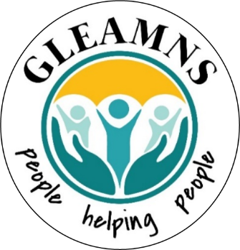

GLEAMNS Human Resources Commission, Inc.

Mission Statement: The mission of GLEAMNS Human Resources Commission, Incorporated, a community-based organization, is to work in partnership with our community to deliver quality services, assistance, and opportunities to eligible customers with emphasis placed on education, employment, and developing self-sufficiency.

2024 Regular Board Meeting Schedule

The GLEAMNS Board of Commissioners meets the third Thursday of every other month, beginning in January. Typically, all Board meetings are held in the Board Room of the GLEAMNS Administrative Office, located at 237 N. Hospital Street in Greenwood, South Carolina.
However, in an effort to reduce the spread of the coronavirus, all GLEAMNS Board Meetings

will be held virtually, using the ZOOM platform, until further notice.

Board Meeting dates and location are subject to change as determined by the Board.

Regular meeting dates for the 2024 calendar year are:
January 18, 2024
March 21, 2024

May 16, 2024

July 18, 2024

September 19, 2024

November 21, 2024*

* May be rescheduled to December to be held as a part of Statewide Board Retreat

Administrative Offices
P.O. BOX 1326
237 N. Hospital Street
Greenwood, South Carolina 29648

